**Mythware 2019**

Language Lab

**User Manual>>**

**Catalogue**

Installation 2

1.2 Regular Installation 2

Teacher Side 4

2 Starting Teacher Side 4

2.1 Create an Account 4

2.2 System Login 4

2.3 Power On and Shut Down Student Computers 5

2.4 Sign-in 6

2.6 Begin and Stop Class 8

3 Interface Introduction of Teacher Side 10

3.1 Title Bar 10

3.2 Class Model 11

3.3 Function Bar 11

3.4 Assistant Tool Bar 11

4 Function Introduction of Teacher Side 12

4.1 Manage Class 12

4.2 Manage Group 13

4.3 Check Student Information 14

4.4 Screen Broadcast 16

4.5 Net Movie 19

4.6 Voice Broadcast 20

4.7 Intercom 21

4.8 Monitor & Control 21

4.10 Student Demonstration 25

4.11 Speak 27

4.12 Chat 28

4.23 View 31

4.24 The Functions of Title Bar 33

Student Side 46

5 Starting student side 46

6 The Interface of Student Side 47

7 The Functions of Student Side 48

7.1 Call 48

7.2 Send Message 48

7.3 Request for Help 49

7.4 Record Voice 50

7.5 View recording files 51

7.6 File Submission 51

7.7 View files from teacher 52

7.8 Screen Record 53

7.9 Sign in 54

7.10 Screen Broadcast 55

7.11 Net Movie 57

7.12 Voice broadcast 57

7.13 Intercom 58

7.14 Student Demonstration 59

7.16 Chat 60

8 Student Side Settings 71

8.1 General 71

8.2 Network 72

8.3 Audio Device 73

8.4 Camera 74

8.5Process protection 74

8.6 Screen-Lock on Disconnect 75

8.7 Administrator Password 76

8.8 Uninstall 77

END-USER LICENSE AGREEMENT 79

Technical Support 80

**Copyright Announcement**

Nanjing Universal Networks Co., Ltd. reserves the right to revise this document and to make changes from time to time in the content hereof without obligation to notify any person or persons of such revisions or changes. Information in this document is subject to change without notice.

**Trademarks**

Mythware is a registered trademark of Nanjing Universal Networks Co., Ltd.

Celeron is a registered trademark of Intel Corp.

Pentium is a registered trademark of Intel Corp.

Core is a registered trademark of Intel Corp.

Microsoft is a registered trademark of Microsoft Corp.

Microsoft Windows is a registered trademark of Microsoft Corp.

Microsoft Windows XP is a registered trademark of Microsoft Corp.

Microsoft Windows Server 2003 is a registered trademark of Microsoft Corp.

Microsoft Windows Vista is a registered trademark of Microsoft Corp.

Microsoft Windows Server 2008 is a registered trademark of Microsoft Corp.

Microsoft Windows 7 is a registered trademark of Microsoft Corp.

# Installation

**1 [System](C:/Users/mythware/AppData/Local/youdao/dict/Application/8.5.0.0/resultui/html/index.html" \l "/javascript:;)** **[Installation](C:/Users/mythware/AppData/Local/youdao/dict/Application/8.5.0.0/resultui/html/index.html" \l "/javascript:;)**

**1.1 Installation Environment**

**System Requirements**

Windows Vista/SP1/SP2

Windows Server 2008

Windows 7/SP1

Windows 8

Windows8.1

Windows10

**Hardware Requirements**

**Teacher side**

**Minimum Requirements:** CPU Core E4300, 1Gbytes Memory

**Recommended Requirements:** CPUCore i3, 4Gbytes Memory

**Student side**

**Minimum Requirements:** CPU P4 3.0, 512Mbytes Memory

**Recommended Requirements:** CPU Corei3 ,4Gbytes Memory

**Notework Requirements**

100Mbytes/1000Mbytes Shared Network or Switched Network

### 1.2 Regular Installation

To install Mythware Language Lab, you need to install the following 2 parts:

The teacher side program install on teacher PCs, and the student side program install on student PCs. To be connected with each other, the teacher PC and student PCs must be in the same network segment.

|  |
| --- |
| **Notes** |
| * Teacher PCs must install Voice Box |
| * Student PCs can have Voice Box and install Voice Box version；Or install Virtual sound card version without Voice Box |
| * You must uninstall the old version before installing new version |

**To Install Teacher Side**

1.Connect voice box.

2.Insert the Mythware Language Lab installation CD into teacher computer and let it auto run, and then choose open folder in pop-up dialog and double-click teacher side installation program to open it. If it does not auto run, open the CD manually.

3.Install the program according to the Installation Wizard.

4.You must restart your computer after installation is complete. The program use the default configuration after installation, but you can change the configuration in Option.

**To Install Student Side**

1.Connect voice box.

2.Insert the Mythware Language Lab installation CD into student computer and let it auto run, and then choose open folder in pop-up dialog and double-click student side installation program to open it. If it does not auto run, open the CD manually.

3.Install the program according to the Installation Wizard.

4.You must restart computer after installation is complete. The program use default configuration after installation, but you can change configuration in Option.

# Teacher Side

## 2 Starting Teacher Side

After installation, a shortcut icon will be created on the desktop. The application is created in the system. Double click the shortcut to run teacher side.

### 2.1 Create an Account

Teacher needs to create an account to use the software

**To create an account**

1.Input user name and password in the create account dialog.

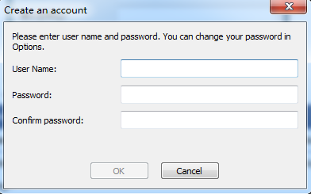

|  |
| --- |
| **Notes** |
| * Create account dialog will pop out automatically when teacher login the system first time. |
| * Teacher can create another account by clicking **Create an account** in the system login dialog. |

### 2.2 System Login

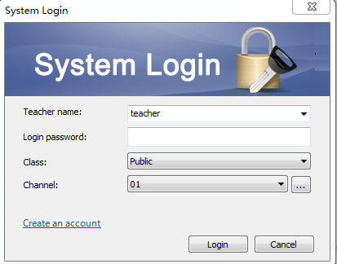

**To Log in System**

1.Double click the shortcut icon , and a system login dialog will pop out;

2.Input teacher name, login password, class and select channel;

3.Click Login button to enter the operating platform of teacher side.

|  |
| --- |
| **Notes** |
| * Click OK button to pop out system login dialog when creating an account. |
| * Click the **Advance** button on the login dialog window, select one or more channels ranging from 1 to 32. |
| * Only students in the same channel can login once teacher choosing the channel. |

### 2.3 Power On and Shut Down Student Computers

Power on or shut down all student computers from the teacher PC.

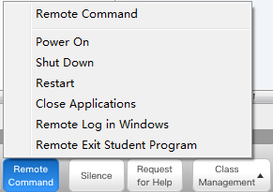

To Power on Student PC

Click Start in Remote Command to power on student PCs.

**To Shut down Student PC**

Click Shut down in Remote Command to shut down student PCs.

### 2.4 Sign-in

Teacher can know the attendance of students by sign-inTo Launch Sign-in

**To Launch Sign-in**

Click Sign-in in Class Management to pop out sign-in dialog;

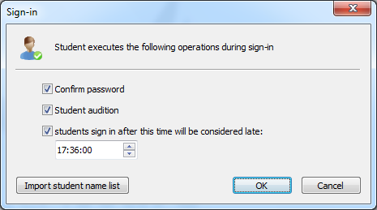

2.The teacher chooses whether launch password confirmation, student audition and set effective time of signing in;

3.Click Import student list to open student list manager, and import student list;

|  |
| --- |
| **Notes** |
| * The usage of student list manager please refer to Student List Manager |

1. Click OK button to begin sign-in, and student screen will pop out sign-in

|  |
| --- |
| **Notes** |
| * **All students icon will switch to not sign-in state until student sign in after clicking OK button by teacher.** |

5.During sign-in, click "Anonymous Mode" to put an end.After finishing Sign in, click Export Sign In Class Management to export the students sign in information into excel file.

**2.5 Voice Device Detection**

Teachers can detect all the devices by only one click. It will detect three aspects as below:

1.Whether voice box connect to the computer correctly.

2.Whether microphone and headset connect to the voice box correctly.

3.Whether microphone and headset run correctly.

**To Detect Voice Device**



1.Click Assistant Tools-Voice Device Detection to pop out voice device detection dialog;

2.Click Start Detection to begin detection;

3.For the devices with problem, the detection result will be shown in red script;

Click Restart Detection to restart detection until all the devices run correctly after dealing with the devices with problem manually.

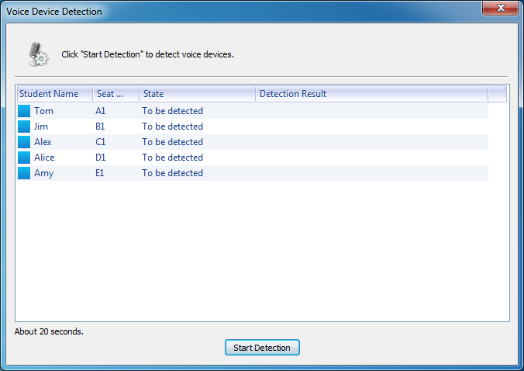

### 2.6 Begin and Stop Class

Begin Class and Stop Class are designed to simplify the operations of teacher when begin or stop a class. These buttons combine the functions teacher may use when beginning or stopping a class, so teacher can select what he needs directly in the dialog.

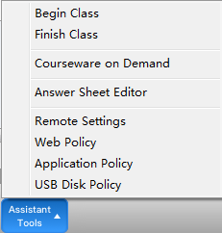

#### 2.6.1 Begin Class

**To Begin a Class**

1. Click  on assistant tool bar to pop out a dialog and select the operations teacher need to use in the dialog;

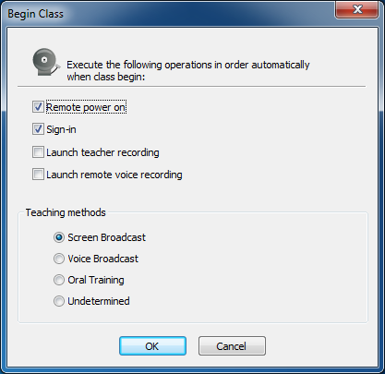

|  |
| --- |
| **Notes** |
| * Execute the operations in order. |

#### 2.6.2 Stop Class

**To Stop a Class**

1.Click  on assistant tool bar to pop out a dialog;

2.Click Change Class button to change class and restart sign-in;

3.Click Shut Down to All to stop class;

4.Click Cancel to cancel this operation.

|  |
| --- |
| **Notes** |
| * All the running functions will stop once teacher stop class. |

## 3 Interface Introduction of Teacher Side

The main interface of teacher side consists of four parts: Title Bar, Class Model, Function Bar and Assistant Tool Bar.

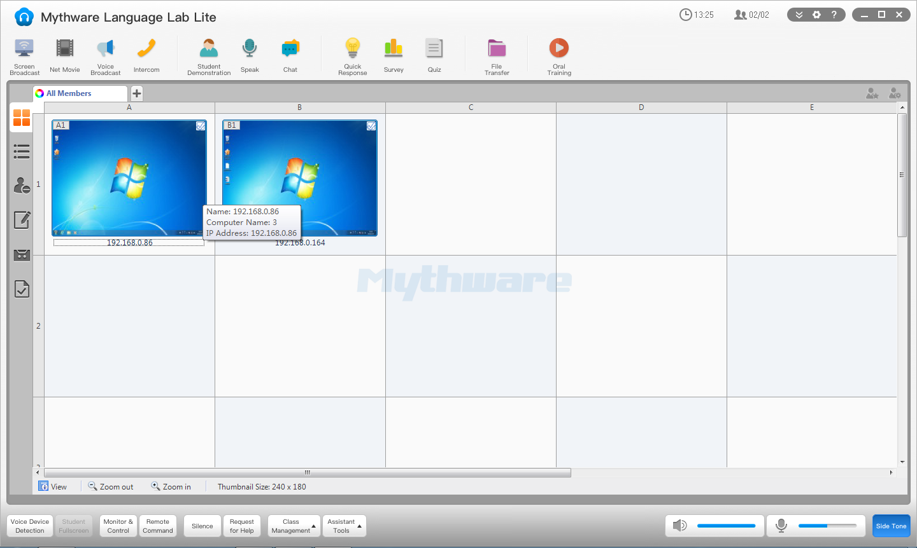

### 3.1 Title Bar

### 

1. It displays time and student number in class.

2. Besides, there are **Menu**, **Option** and **Help** button on title bar. And teacher can minimize, drag and drop or close the software.

3.If the program has been minimized, a floating toolbar will appear at the top of your screen.



This toolbar allows you to perform many common operations as bellow: **Screen Broadcast**, **Voice Broadcas**t, **Net Movie**, **Oral Training**, **Monitor & Control**, **Launch Application**, **File Distribution**, **Silence On** and **Silence Off**.

Teacher can hide and lock the floating bar.

### 3.2 Class Model

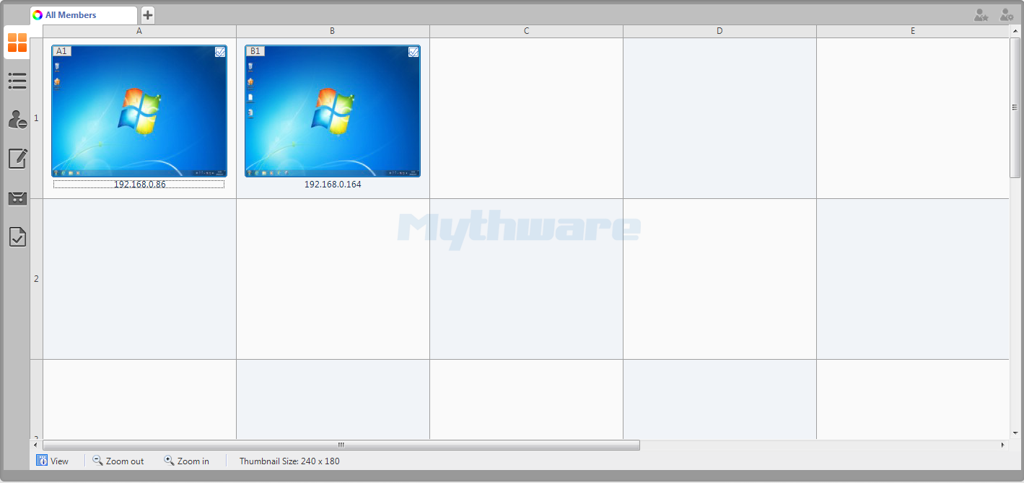

There are six different view of class model: **Monitor View**, **Report View**, **Policy Control View**, **Test View**, **Remote Voice Recording View** and **File Submission View**.

Teacher can check student information and zoom in or zoom out student icon in class model.

### 3.3 Function Bar

### 

The function bar is under title bar,it contains the operations as below: **Screen Broadcast, Net Movie,Voice Broadcast, Intercom, Student Demonstration, Speak, Discuss,Response and Competition,Survey,Test, File distribution, Oral Training.**

### 3.4 Assistant Tool Bar



Assistant Tool Bar contains the operations as below: **Equipment check,Student Fullscreen,Monitor,Remote command, Slience,Request for Help, Class management, Course preparation.**

Click class management to pop out the operations: **Class management, Student list management, Lock the seating, Sign-in, Display name in student side and etc,.**

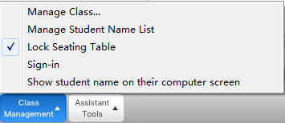

Click Course preparation to pop out the operations: **“Begin Class, Stop Class, Select Courseware ", "Answer Sheet Editor", "Repeat Courseware Editor", "Remote Setting", "Internet Management", "Application Management", "U disk Management"**

In volume adjustment part, we can set the system volume and the microphone's sound, and select whether to use the speaker to play and whether to listen.

## 4 Function Introduction of Teacher Side

### 4.1 Manage Class

Click **Menu-Manage Class** on title bar to pop out a dialog as below, teacher can manage class in this dialog.

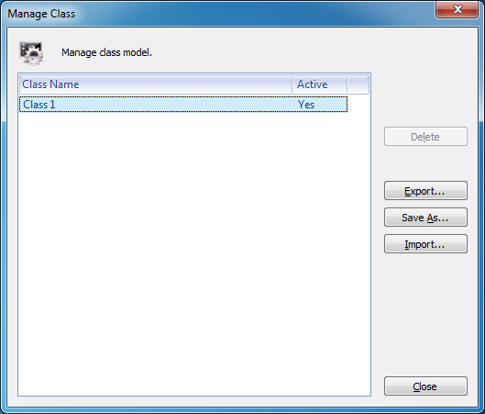

To Manage the Class

1.Click **Export** to export class model information;

2.Click **Save As** to save class model;

3.Click **Import** to import a class model;

4.Click **Delete** to delete class model.

### 4.2 Manage Group

Teacher can divide into different groups in class model. There are three different methods:

One: Drag student icon to, pop out edit group dialog automatically;

Two: Click button, pop out edit group dialog automatically;

Three: Right click student icon, select **Group-New Group** to pop out edit group dialog.

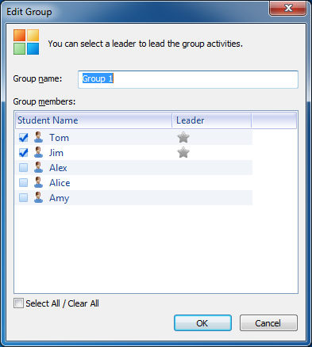

Teacher can set group name and select group leader in edit group dialog. And there are three different methods to select group leader:

One: Click to turn to in edit group dialog;

Two: Select student and then click in group view;

Three: Right click student icon to make him group leader in group view.

|  |
| --- |
| **Notes** |
| * Click can edit the group in group view. |

### 4.3 Check Student Information

Teacher can not only check student state directly by student icon, but also by clicking  button.

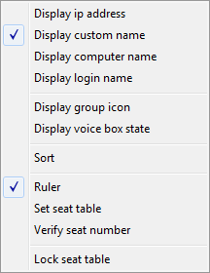

Steps for setting display information in Class model.

1.Click View button to choose the display information which will show in Class Model.

2.The teacher can choose Display group color under Group state, easy for judging students groups.

3.The teacher can display students’ voice box state.

4.Click Sort button to sort the students in Class model. When using Ruler, it can support to sort by names, and set Seating table and Verify seat number; when don’t use Ruler, it can support advanced sorting, and also Align icons and Reset icons.

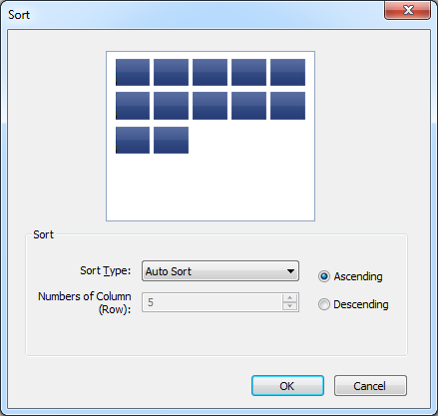

Click Lock Seating Table button to lock the seat table, the students icons can’t be moved. And the new attendance student’s background color is fluorescent yellow.

|  |
| --- |
| **Notes** |
| * Unable to view when locked |
| * Student icons will turn yellow when locked |
| * Student icons will be locked automatically when executing teaching functions. |

### 4.4 Screen Broadcast

Screen broadcast is the most important function of this software, it can broadcast teacher’s screen and voice to the students. Teacher can also communicate with students when screen broadcast.

To Launch Screen Broadcast

1.Choose the students in class model, click **Screen Broadcast** to broadcast teacher’s screen and voice;

2.There will be a screen broadcast toolbar as below when screen broadcasting;



Then, how to use the screen broadcast toolbar:

**Show or Hide Window:** Show or hide the interface of teacher side;

**Pause or Resume Screen Broadcast:** Pause or resume screen broadcast when screen broadcasting;

**Screen Pen:** The interface of screen pen as below:

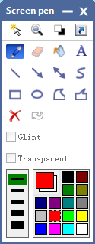

There are **Pointer**, **Magnify**, **Switch background** and **Set shortcut key** in the top row of screen pen.

Teacher can use **Pointer** and **Magnify** to highlight the point, use **Switch background** to turn the screen to white or black and use **Set shortcut key** to set shortcut key.

**Broadcast EZ-CAM:** Correspondwith external device in the main interface, and teacher can broadcast the image and video by connecting external devices;

**Turn on Camera:** Correspondwith camera in the main interface, and teacher can live broadcast the image by turn on camera;

**Screen Record:** Record the teaching process;

**Set Display Properties:** There are four properties can be chosen as below

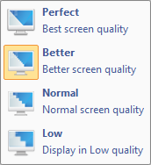

**Set Screen Display Mode:** There are three modes can be chosen as below

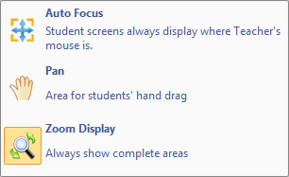

**Exit Screen Broadcast:** Click this button to exit screen broadcast;

**Contract or Expand:** To contract or expand screen broadcast toolbar.

|  |
| --- |
| **Notes** |
| * There will be pop out a dialog as below if you use screen broadcast the first time, you can select **Do not prompt again** to forbid the prompt next time. |

### 4.5 Net Movie

Net Movie is made up of channels and files. Teacher create channel to play different media files, different channel can play different media files, and students can choose the channel by themselves. What’s more, net movie can not only play local media file, but also live broadcast external device.

To Launch Net Movie

Click **Net Movie** to pop out net movie dialog as below:

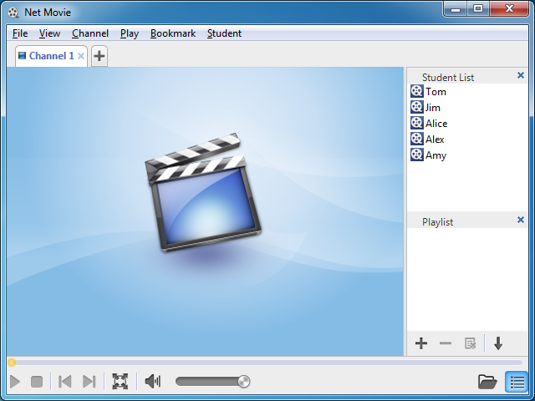

1.Click **File-Open Media Files** or Click  to open media file;

2.Click **Channel- New Channel** or Click to add channel, different channel can play different media files;

3.Type in channel name and choose to play media file or live broadcast external device when adding channel;

4.Students choose the channel to watch;

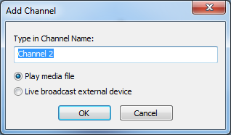

|  |
| --- |
| **Notes** |
| * Teacher needs to deploy external device before live broadcast external device. |

1.Click  to add media file, click  to delete media file, click  to clear playlist, and click  to change playback mode;

2.Click  to make net movie dialog full screen, and click  to resume;

3.Click View-Student List or View-Playlist or  to hide or show the lists;

|  |
| --- |
| **Notes** |
| * The software will create a channel named channel 1 when launching net movie. |
| * Allow eight channels at most in net movie, including two external device channels. |
| * Can’t delete channel when there is only one channel. |
| * Channel name can’t be the same. |

### 4.6 Voice Broadcast

Voice broadcast is one of the main functions of this software, which can broadcast the voice of microphone and computer of teacher side to the students.

To Launch Voice Broadcast

1.Choose the students in class model, click **Voice Broadcast** to broadcast voice of teacher side;

2.Adjust the volume of playback and microphone by dragging process bar.

### 4.7 Intercom

Intercom is different from speak, intercom can only be used between teacher and selected student, other students can’t hear the voice.

To Use Intercom

1.Click **Intercom** on function bar;

2.Choose the students to talk with in class model, eight students at most once;

3.Click **Intercom** again to exit intercom.

|  |
| --- |
| **Notes** |
| * Teacher can switch between speak and intercom. |

### 4.8 Monitor & Control

Monitor was initiated by teacher, which can remotely monitor and view the student interface. Meanwhile, teachers can also conduct corresponding operations.

**To launch Monitor & Control**

1. Click Class Management-Monitor & Control, the screen of teacher side will display the desktop of four students. Below each student screen, it will show the student seat number, student name and machine name. 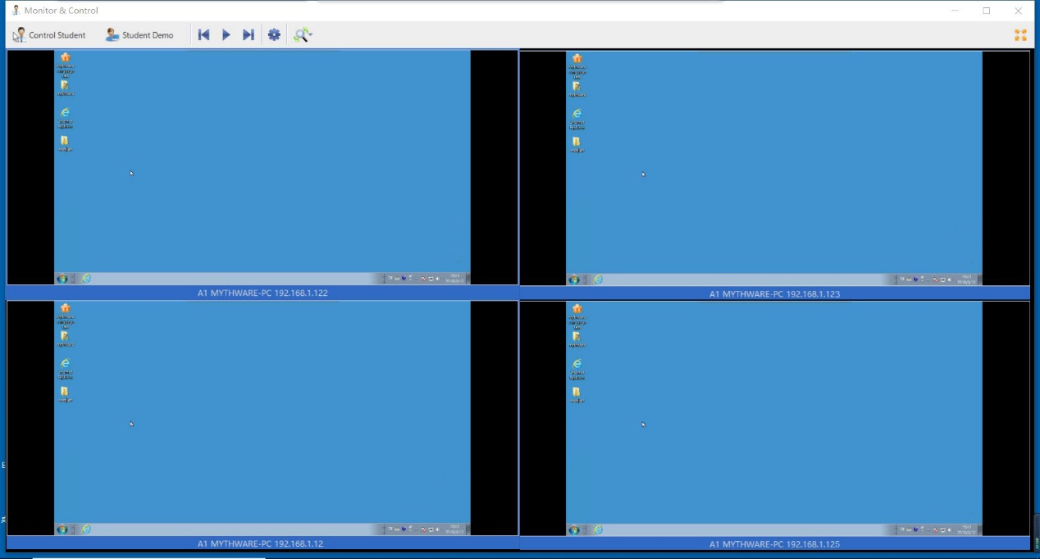

 2. In this mode, teacher can monitor students screen through the loop play, and set up a slider time byin tool bar.

Click to turn to the next page automatically;

Click to display previous screen;

Click to display next screen;

3.Click to change the 3 view mode as below:

**A**uto Focus: The monitor screen of the teacher focus follow student’s mouse, which can only show the screen within a certain range of the student's mouse.

**Pan:** Drag the display area by hand

****Zoom display: screen always display the whole area.

1. Click to broadcast one student’s screen to others;

5.Click to monitor only one student;

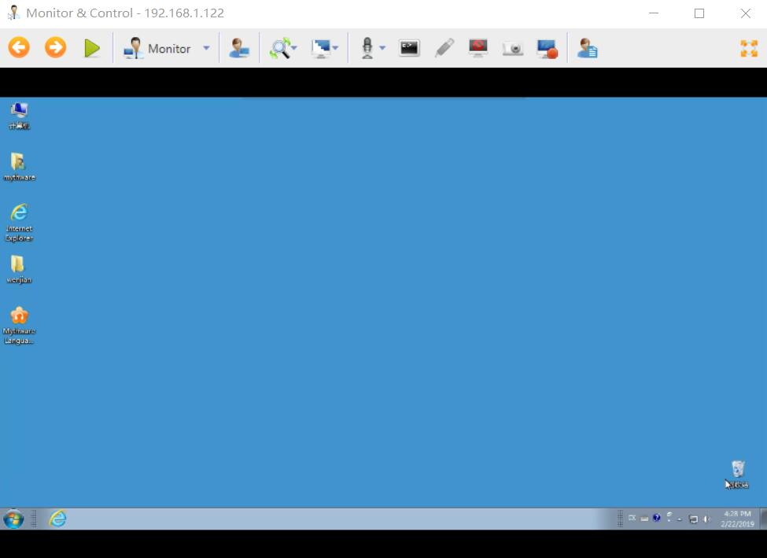

6.Choose the way to remote control students from the list as below:

Teacher and student can both control the computer, teacher can do operations on student side

Only allow the student control the computer, teacher only can monitor.

Only allow teacher control the computer

7.There are still some other functions can be used when monitoring single student

Broadcast one student’s screen to others;

****Change the view mode between Pan and Zoom display;

****Change display quality

Audio Setting: Set audio mode from the list as below

Remote Open Application: Teacher can open the applications as below

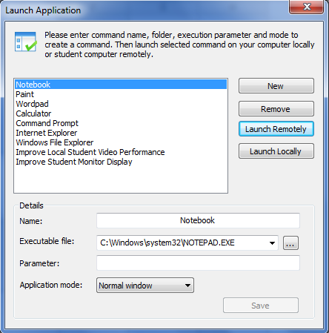

****Screen Pen: The same as screen pen of screen broadcast;

****Silence: Blank student screens to gain attention;

Snapshot: Save a snapshot;

****Screen Record: Record the teaching process.

Student Properties: Display the student’s computer information, open

application and process

|  |
| --- |
| **Notes** |
| * Teacher can double click the students icon in class mode directly to remote control single student. |

8.Click **Close** to exit Monitor & Control.

#### 4.9 Remote Command

Teacher can execute the operations as below:

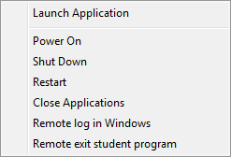



### 4.10 Student Demonstration

The software allows teacher to select a student to demonstrate the operations of his desktop to the others. Teacher can take control of the student's mouse and keyboard, share control with the student or let the student keep control of the mouse and keyboard. Teacher can also talk with the selected students during the demonstration.

To Launch Student Demonstration

1.Choose the student to demonstrate in class model, click **Student Demonstration** to pop out a dialog as below:

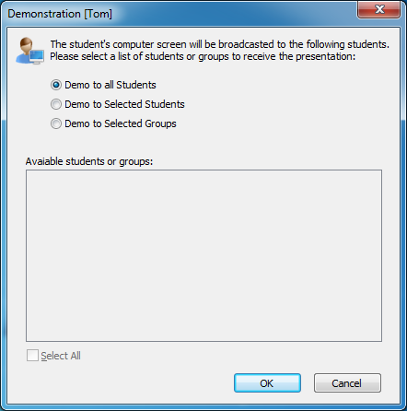

1. Select the students or group to receive the demonstration, click OK to begin student demonstration;



1. In monitor mode, teacher can take part in student demonstration and select different way as below.

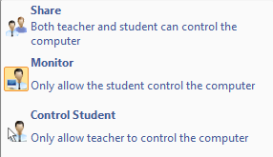

"Open application" means to create, remove, open a local student application remotely

In Share mode, teacher and student can both control the computer of demonstration students.

In Monitor mode, only student can control the computer.

In Student Control mode, Only allow teacher control the computer

|  |
| --- |
| **Notes** |
| * See monitor and control for more details |

1. Click **Close** to exit Monitor & Control and Student Demonstration.

### 4.11 Speak

Speak can enhance the communication between teacher and student. Teacher can invite student to speak during class, and broadcast the voice to other students.

To Speak

1.Click Speak on function bar;

2.Choose the students to speak in class model, eight students at most once;

3.Click Voice Broadcast to exit speak.

|  |
| --- |
| **Notes** |
| * Voice broadcast will be launched automatically when speak. |
| * There will be a trace for the student who has spoken:     before speak after speak |
| * Click student icon can invite student to speak directly when screen broadcast, voice broadcast, oral training and live broadcast. |
| * Click **Speak** again only exit speak, remain voice broadcast. |

### 4.12 Chat

**4.12.1 Group Chat**

Teacher can launch chat activity and set the rules. When launch chat activity, students interface will be as below:

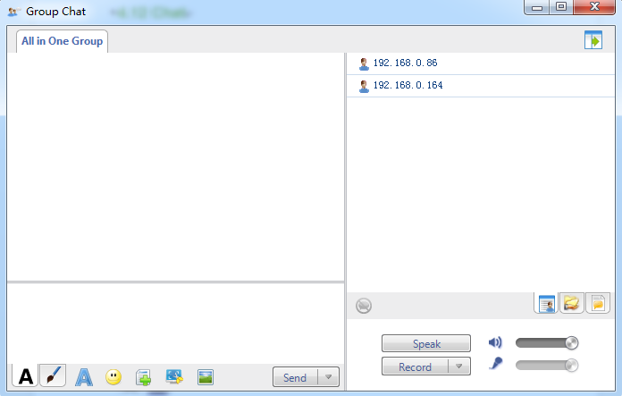

To Launch a group chat

1. Students edit the content in dialog ;

** edit**

Change message font: Set font, font style, size, color, effects, script of messages

in the dialog;

Insert Emoticon: Send emoticon to make chat easy and funny

**Draw and Send Picture**

Pen: Draw the picture manually;

Eraser: Erase the picture;

Undo: Undo previous step

Rework: Rework previous step;

Color: Choose the color;

Select Background: Select background from empty, small grid, medium grid

and large grid;

1. Click **Send** to send to other students in the same group;
2. Click Speak in the right side of interface to chat with others with voice and simultaneously recording; you can open the recording files in recording folder.
3. There are also three different views in chat dialog as below:

Chat Members View

Teacher and students can check other members in the same group.

 Shared Files View

Teacher and students can check the shared files, and double click the open the shared file.

****Chat History View

Teacher and students can check chat history in this view

|  |
| --- |
| **Notes** |
| * After teachers share files in one chat group, students can view or download the Shared files |
| * Students can click "send" and select "send". |

**4.12.2 Topic Chat**

Teacher creates several topics for students choose. When launch topic chat activity, students interface will be as below:

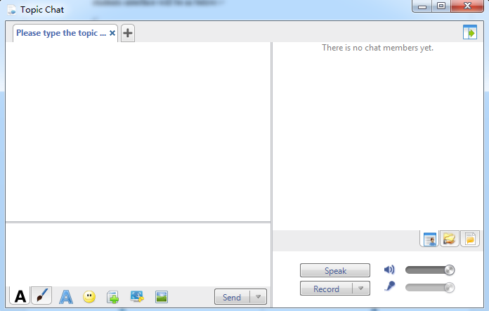

students choose the topic they are interested in to chat with others in the same group,students interface will be as below:

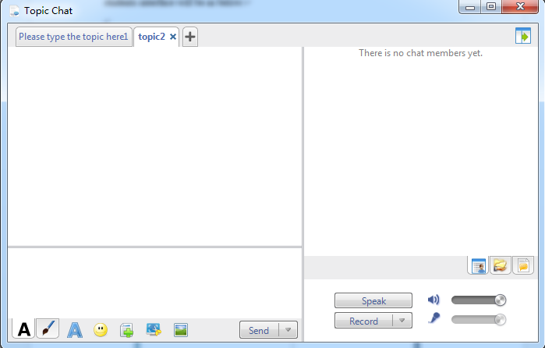

Re-select topic chat steps:

1. In the”**Topic Chat**” dialog, click “**Topic List**”.
2. Select Topic, click “**Enter**”

### 4.23 View

This software provides 6 kinds of views, and they are Monitor View, Report View, Policy Control View, Test View, Remote Voice Recording View and File Submission View.

#### 4.23.1 Monitor View

Monitor View is the most important view of this software. In this view, teacher can see the states of students directly. The following table shows the various icons and the meanings of each icon.

|  |  |  |  |
| --- | --- | --- | --- |
| State Icon | Description | State Icon | Description |
|  | Student is calling. |  | Student is receiving Screen Broadcast. |
|  | Student is receiving Voice Broadcast. |  | Student is attending Oral Training. |
|  | Student is speaking. |  | Student is talking with teacher through intercom. |
|  | Student is chatting with others. |  | Student is receiving Net Movie. |
|  | Student is attending Quiz. |  | Student is attending Oral Test. |
|  | Student is being required to keep silence. |  | Student is being monitored by teacher. |
|  | Student is attending Group Teaching. |  | Student is receiving live broadcast. |
|  | Student is receiving files. |  | Student is attending Survey. |
|  | Student is making simultaneous interpretation. |  | Student is voice chatting. |

#### 4.23.2 Report view

In this view, teacher can see the detail information of student side, such as Student Name, Computer Name, IP Address, MAC, State of Audio Device and processes. Besides, teacher can define the information displayed in this view.

#### 4.23.3 Policy Control View

Policy Control View consists of Web Policy, Application Policy and USB Disk Policy. The functions of this view refer to Web Policy,Application Policy and USB Disk Policy.

#### 4.23.4 Test View

After teacher click Test button, it will auto switch to Test View. In this view, teacher can see the information of tests launched recently and execute some operations on these tests, such as Test, View and Delete.

#### 4.23.5 Remote Voice Recording View

After teacher click Remote Voice Recording button, it will auto switch to Remote Voice Recording View. The functions of this view refer to Remote Voice Recording.

#### 4.23.6 File Submission View

The functions of File Submission View refer to File Submission Policy.

### 4.24 The Functions of Title Bar

#### 4.24.1 Language Changing

Teacher is able to change the language.

#### 4.24.2 Menu

The Menu has the following functions.

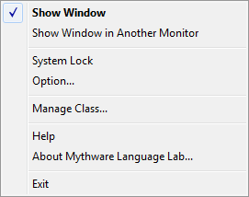

If the teacher starts the class with dual monitor, he can click Show window in another monitor button to switch the window of teacher side software between two monitors.

Teacher can click System Lock button to lock this software. And he should enter the password to unlock this software.

Teacher can click Option button to open Option dialog. The detail information please refers to Option.

Teacher can click Manage Class button to open Manage Class dialog. The detail information please refers to Manage Class

Teacher can click Help button to open the help documentation of this software.

Teacher can click About Mythware Language Lab button to view the version, user name, company name, serial number, user number and time limit.

Teacher can click Exit to exit this software.

#### 4.24.3 Option

In Option, teacher can set the software according to their need.

##### 4.24.4 Class Model

Teacher can set the interval for thumbnail update and whether to show notification upon successful student connections in this tab.

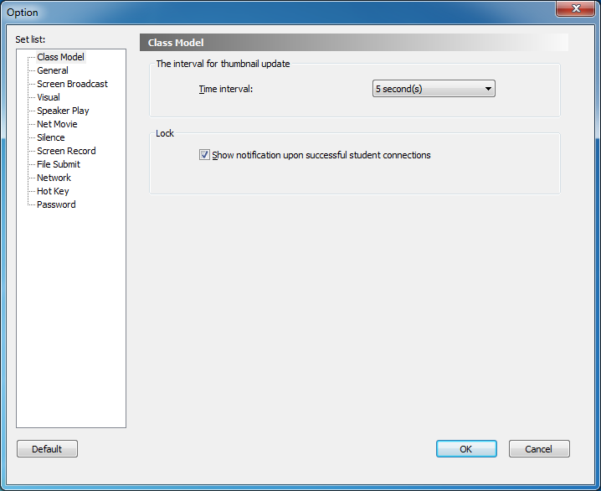

##### 4.24.5 General

In this tab, teacher can set the root directory to save the user files and the information about Call, Remote message and Student session.

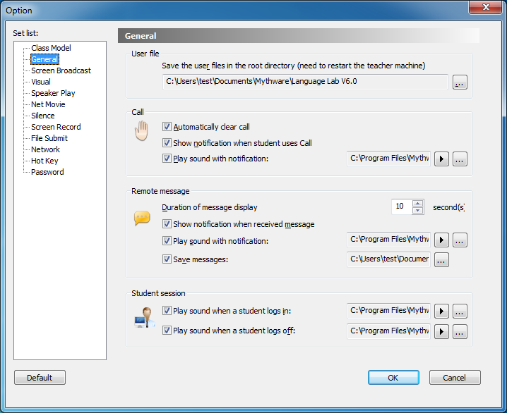

##### 4.24.6 Screen Broadcast

In this tab, teacher can select the default mode of student side during **Screen Broadcast** process. Besides, teacher can set the saving path and performance of screen record during **Screen Broadcast** process.

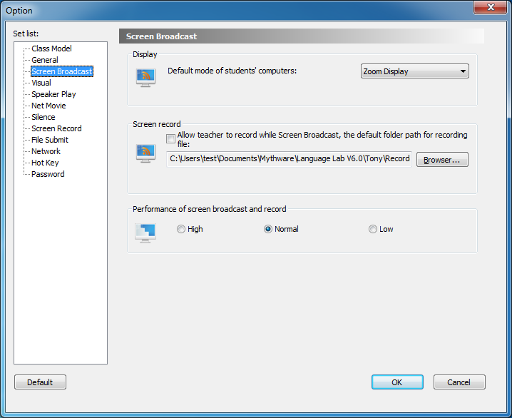

##### 4.24.7 Visual

In this tab, teacher can set the maximum number to launch Visual at the same time.

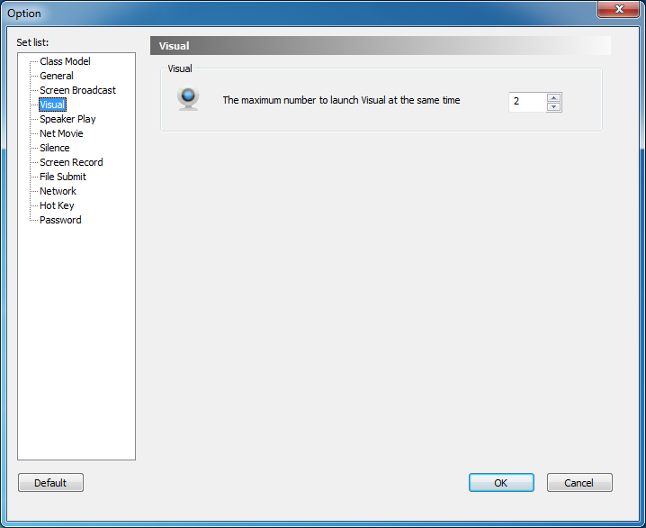

##### 4.24.8 Speaker Play

In this tab, teacher can select the speaker output device.

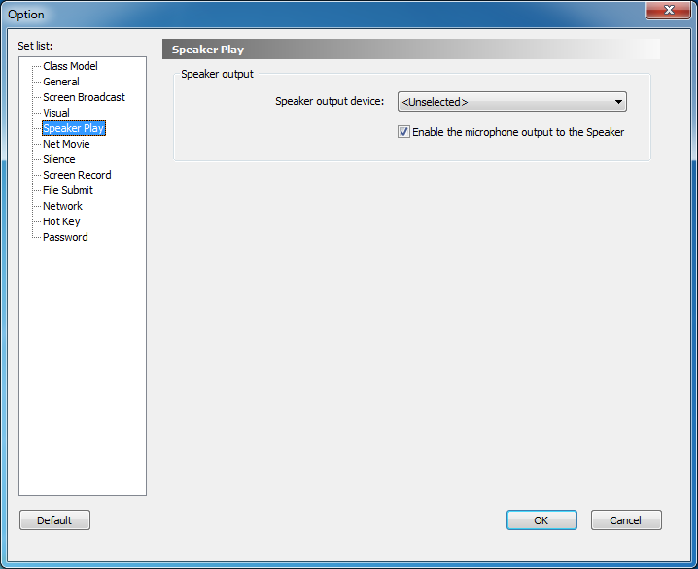

**4.24.9 Net Movie**

In this tab, teacher can set the buffering of net movie.

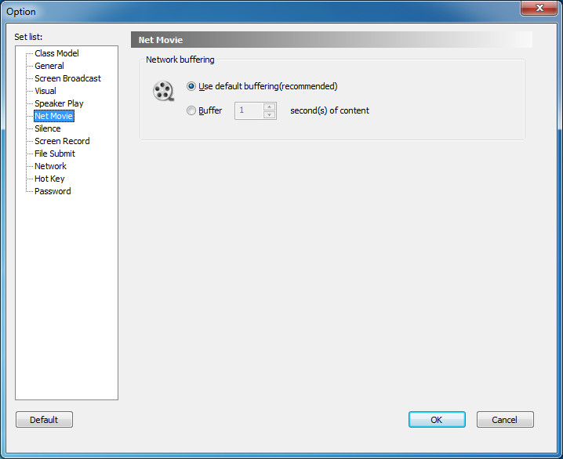

**4.24.10 Silence**

In this tab, teacher can set the content, text color and background color of the message which displays on students’ screen when executing **Silence**.

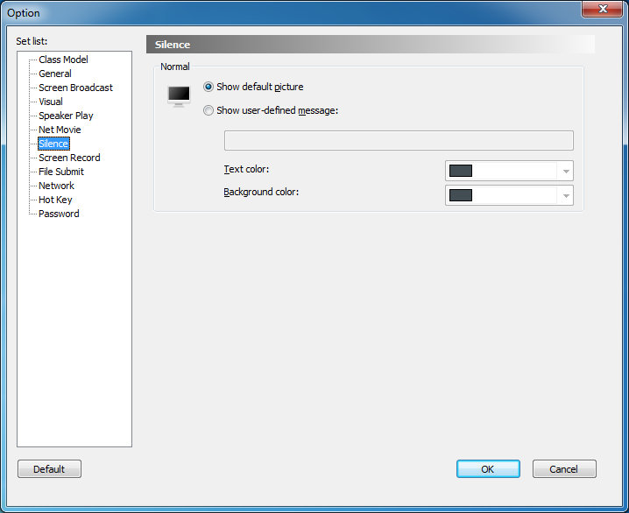

**4.24.11 Screen Record**

In this tab, teacher can set the quality scheme, recording scheme, and whether to record the voice during screen record.

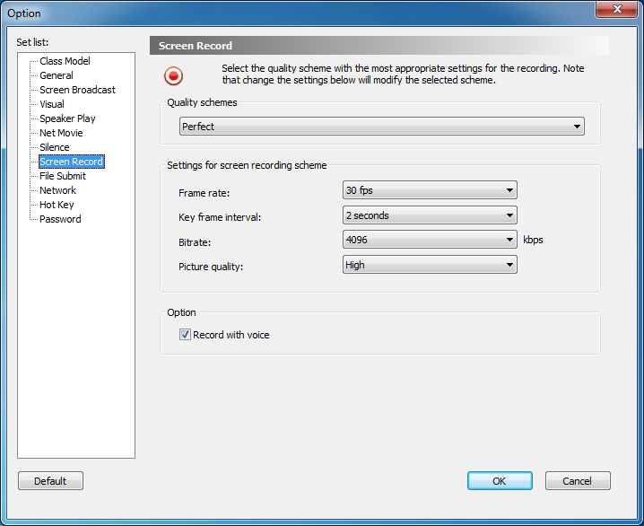

**4.24.12 File Submission**

In this tab, teacher can select the folder which is used to save files submitted by students, and they can set the limitation of file size and number.

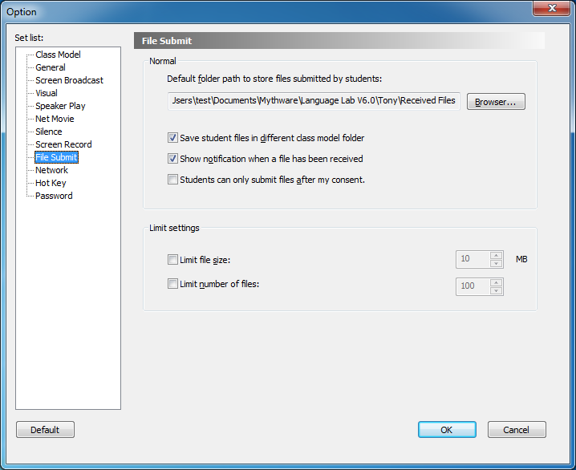

**4.24.13 Network**

In this tab, teacher can select an IP address to bind with teacher side and set the latency period of network. Besides, he can set some other fields of network.

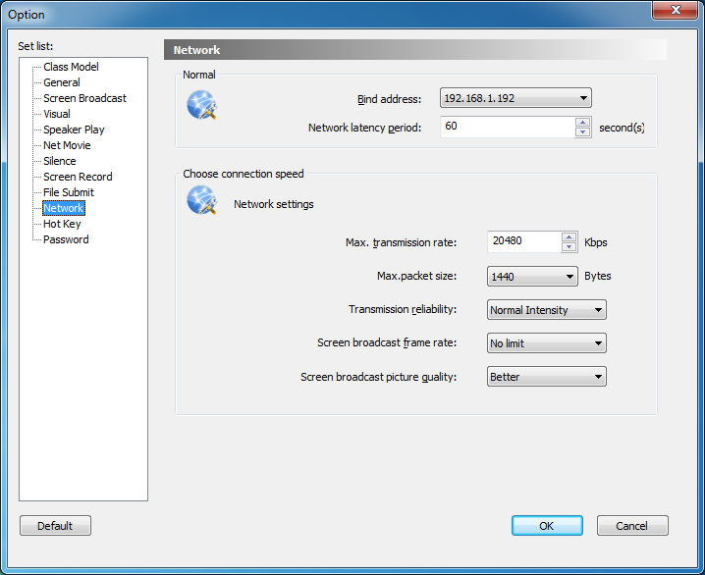

##### 4.24.14 Hot Key

In this tab, teacher can set hot key for some common functions.

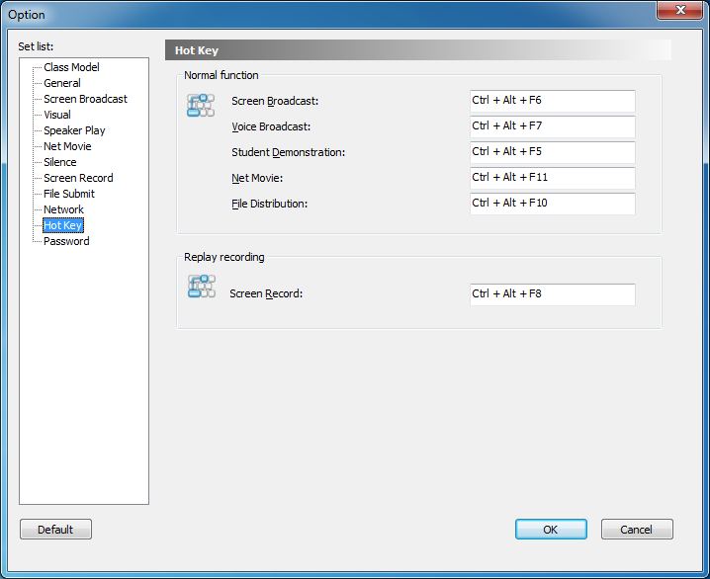

##### 4.24.15 Password

In this tab, teacher can set the Login password.

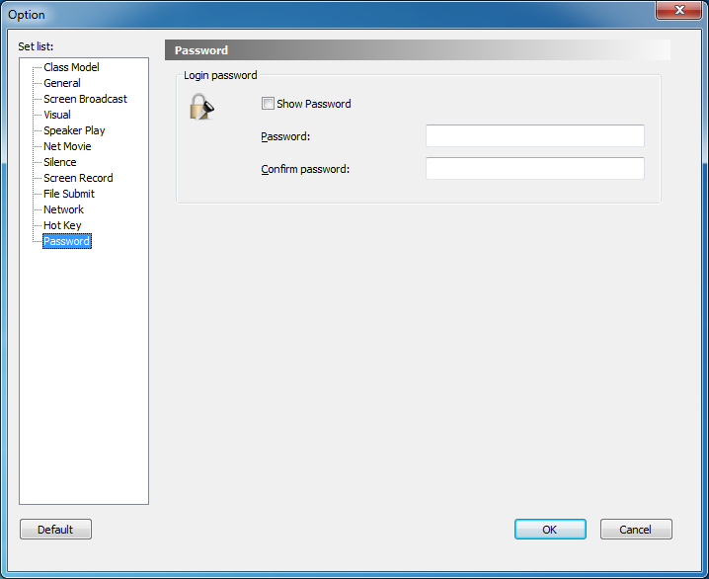

# Student Side

## 5 Starting student side

The default settings of student side

1.Auto initiate student side when the system starting;

2.Auto login to the teacher side of the same channel after starting student side;

3.Auto minimize to task bar after login. If the connection is not successful, the icon in task bar is gray.

4.To prevent student side from out of the control of teacher side, the student side is equipped with functions such as Process protection and Screen-Lock on Disconnection.

5.To prevent students from changing the settings of student side, the student side is equipped with Administrator password.

## 6 The Interface of Student Side

After the student side is initiated, the following toolbar will display on the top of the desktop.

D:\捕获.PNG

 **Volume setting:** to adjust the volume of computer and microphone.

 **Call:** to call teacher.

 **Send message:** to send messages to teacher.

** Request for help:** to ask teacher for help when having problem.

** Record voice:** to record and save the voice of computer and microphone.

 **View recording files:** to open the folder which is used to save recording files.

** File submission:** to submit assignments to teacher.

** View files from teacher:** to open the folder which is used to store the files received from teacher.

** Media on demand:** to demand the courseware provided by teacher.

## 7 The Functions of Student Side

### 7.1 Call

Students can use this function to call teacher during the class.

To Launch a Call

1.Click  icon on floating toolbar;

2.After launching a call, this student’s icon in **Monitor View** of teacher side will become **Call** state.

|  |
| --- |
| **Notes** |
| * Students are not allowed to call when the **Call** function is disabled by teacher. If the teacher set the call policy as **Auto Answer**, Students will access to the state of **Speak** after launching a call. |

### 7.2 Send Message

Students can communicate with teacher by sending text message during the class.

To Send Message

1.Click  icon on floating toolbar, and then the following dialog will pop up:

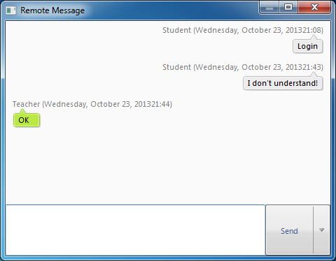

2.Type text message in the input box;Click  button to send.

|  |
| --- |
| **Notes** |
| * Click the **Insert Phrase** button and you can insert common phrases in the input box. |
| * If the **Send Message** function is disabled by teacher, students will not be allowed to send message and the **Send** button will be gray. |
| * Set the hot key as Enter or Ctrl +Enter. |

### 7.3 Request for Help

If students have any problems, they can click  button to ask teacher for help. And then the following dialog will pop up.

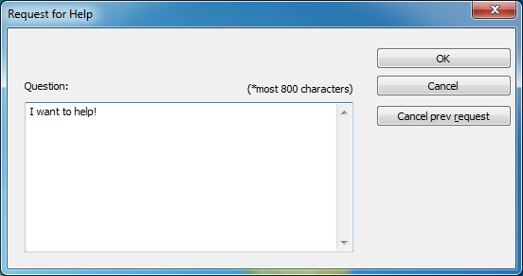

To Request for Help

1.Type the problems in the input box;

2.Click OK to send the request to teacher.

### 7.4 Record Voice

Students can use this function to record the voice of computer and microphone.

To Record Voice

1.Click  button on floating toolbar;

2.Click  button on floating toolbar to stop recording.

|  |
| --- |
| **Notes** |
| * It will record 2 files after students click **Record Voice**, one of them only contains the voice of microphone, while the other contains the voice of computer and microphone. |

### 7.5 View recording files

Students can use this function to open the folder which is used to save recording files.

To Check the Recording Files

1.Click  button on floating toolbar;

2.The folder which is used to save recording files pops up.

|  |
| --- |
| **Notes** |
| * This button is gray when recording is not performed. |

### 7.6 File Submission

### Students can use this function to submit assignments. After they click button, the File Submit dialog will pop up.

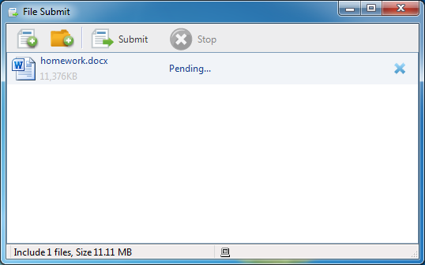

To Submit Files

1.Click  button on floating toolbar;

2.Click  button to add a file, or click  button to add a folder;

3.Repeat step 2 until you have added all the files and folders you want to submit;

4.Click  button to send the file submission request to teacher. If the teacher accepts the request, these files will start submitting automatically. If the teacher rejects the request, the student will get a message:” **Submission rejected!** Teacher doesn't want you to submit any files now. Please submit later.”

|  |
| --- |
| **Notes** |
| * Teacher is able to change the **File Submit** policy. If the teacher set the policy as **Enable**, the files will start submitting after the teacher allows. If the teacher set the policy as **Disable**, the student will get a message:” **Teacher won’t allow student to submit files now, please try later.**” |
| * If the teacher allows students submit files without his consent, the files will start submitting after students click button. |
| * The teacher is able to set a limit on the number and size of the files submitted at a time. If the file submitted by students beyond the limitation, these students will get corresponding prompts. |
| * Students can click **Stop** button to stop this submission during **File Submit** process. |

### 7.7 View files from teacher

Students can use this function to open the folder which is used to save files received from teacher.

To View Files

1.Click  button;

2.The folder which is used to store the files received from teacher pops up.

|  |
| --- |
| **Notes** |
| * If the teacher doesn’t provide any file, this button will be gray. |

### 7.8 Screen Record

In order to facilitate after-school learning, students can start up a screen record by themselves.

To Record the Screen:

1.Click the  icon on task bar;

2.Select **Screen Record** button in the pop-up menu.

3.Specify the save path and filename for the recording file, and click **OK** button.

4.A floating toolbar appears on the screen, and a red flash button indicates that the record has started.

5.Students operate on their mission, and operations are recorded background.

6.To stop recording, click  button on the floating toolbar.

7.Screen record completed.

Floating toolbar is as following:



 **Screen Pen:** To add annotation during **Screen Record**.

 Start recording.

 Pause **Screen Record.**

 Stop recording**.**

|  |
| --- |
| **Notes** |
| * To play the screen-recorded files via **Windows Media Player**, your computer must have installed the software. |

### 7.9 Sign in

After teacher launches **Sign- in**, the following dialog will pop up on students’ desktop.

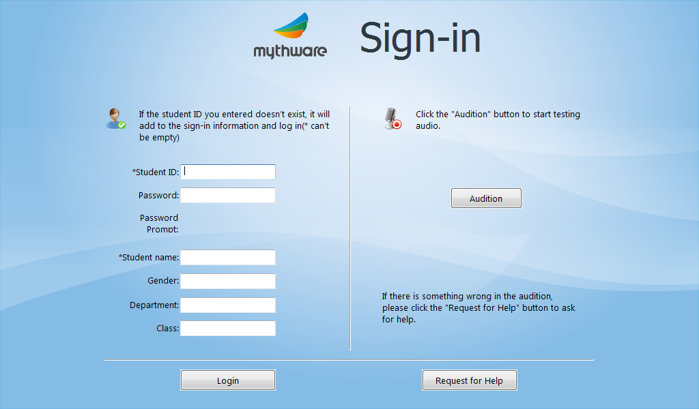

To Sign In

1.Enter sign-in information such as Student ID, Password, Student name, Gender, Department, Class and so on in input box;

2.Click the **Audition** to verify the headphones use normally;

3.Click **Login** button;

4.Confirm the information in **Confirm sign-in information** dialog;

5.If the information is correct, click **OK** button to sign in; otherwise, click **Cancel** to re-enter the information;

6.Re-click **Login** to complete **Sign in**. If the students meet problems, they can click **Request for Help** to send a request to teacher

|  |
| --- |
| **Notes** |
| * If teacher select Password Confirmation, students need to enter Student ID and Password. Otherwise, students just need enter Student ID. |
| * If the information of one student is in the **Student List Manager**, he just need to enter Student ID and Password, and the **Confirmation** dialog will pop up automatically. |
| * If the information of one student is not in the **Student List Manager**, he need to enter Student name, Gender, Department, Class (Student name is necessary). |

### 7.10 Screen Broadcast

If teacher launch Screen Broadcast with full screen mode, the student side will receive the broadcast in full screen. As the following picture, the floating toolbar will display on the top of the desktop.

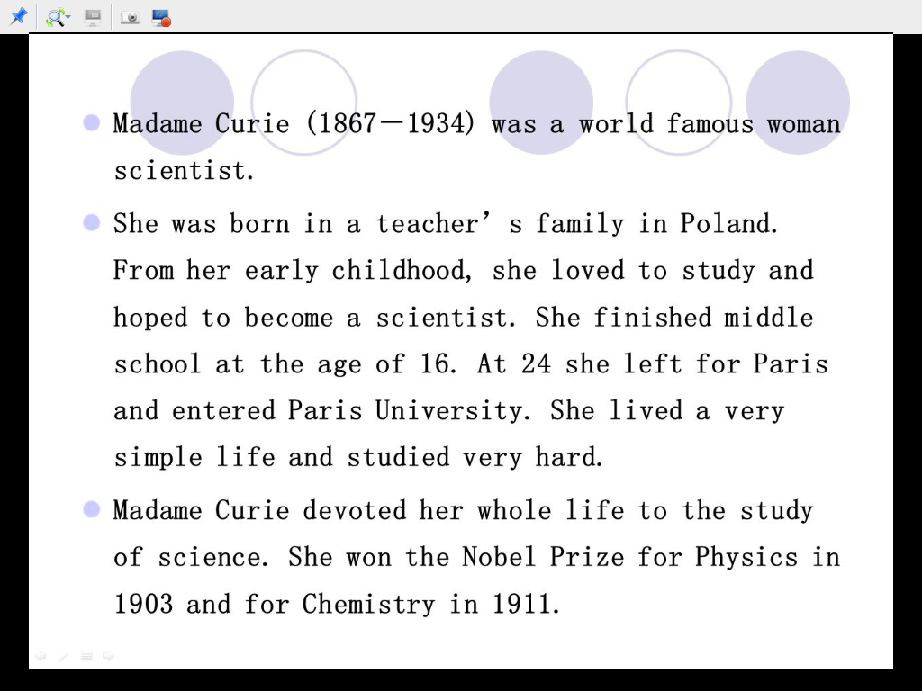

Students can execute the following operations with the floating toolbar.

**Lock**

Lock the floating toolbar on the top of screen. The operation steps: click the  button on the floating toolbar.

**Change view mode**

Change the mode of students view teacher side screen, and there are 3 view modes as following.

Auto Focus

Focus follows mouse movement.

**1.Pan**

Drag the display area by hand. It can be used with **bird’s view**, and the full view of teacher side screen displays in **bird’s view**.

**2.Zoom Display**

Screen always displays the whole area. And it is the default view mode.

**Snapshot**

Save the current screen as a picture, and the format of the picture is JPEG.

**Screen Record**

Record the content of **Screen Broadcast** for after-school review. The format of the video is ASF.

|  |
| --- |
| **Notes** |
| * Teacher is able to choose the mode in which students receive **Screen Broadcast**, full screen or window. |

### 7.11 Net Movie

The following dialog will display on students’ screen after teacher launches **Net Movie**. Students can choose one channel to view in channel list.

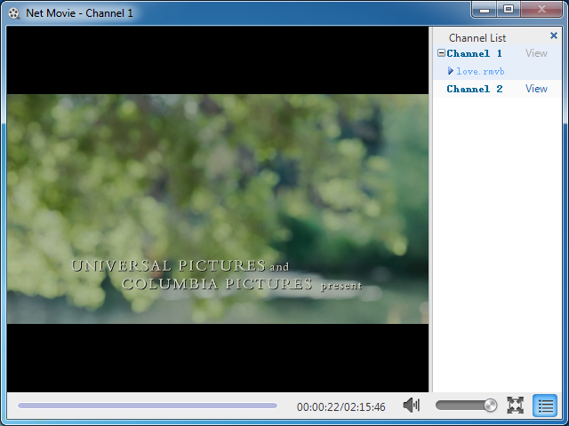

To Choose Channel

Select one channel in channel list and click **View** beside this channel.

|  |
| --- |
| **Notes** |
| * If there is only one channel, students can’t choose. |

### 7.12 Voice broadcast

After teacher launches this function, students will hear the voice of computer and microphone of teacher side. ­­­­­If students receive **Voice Broadcast** in full screen, their screen will be as below.



|  |
| --- |
| **Notes** |
| * Teacher is able to choose the mode in which students receive **Voice Broadcast**, full screen or window. |

### 7.13 Intercom

**Intercom** is similar with **Speak**, and the different between two functions is whether the voice of speaking students will be broadcast to other students.

If teacher invite certain student to attend **Intercom**, the following dialog will display at the low right of students’ screen.

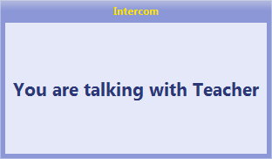

If teacher launches **Visual** while inviting certain student to attend **Intercom**, the following dialog will display at the low right of students’ screen.

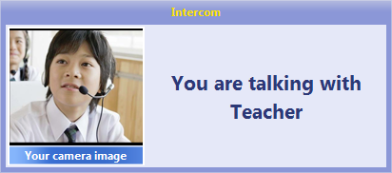

### 7.14 Student Demonstration

Teacher selects one student to broadcast his screen to other students. The screens of other students will be the same with **Screen Broadcast**.

|  |
| --- |
| **Notes** |
| * Teacher can monitor, control or share with this student during **Student Demonstration** process. |

**7.15 Speak**

Teacher can launch Speak during Screen Broadcast, Voice Broadcast, Oral

Training process. If teacher invite certain student to speak, this student’s screen will be as following picture.

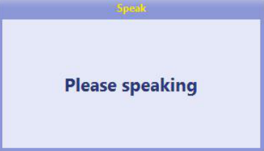

If teacher launches Visual while inviting certain student to speak, this student’s screen

will be as following picture.

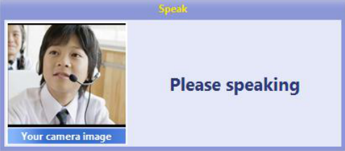

### 7.16 Chat

#### 7.16.1 Group Chat

Students’ screen displayed as below when teacher launch **Group Chat**.

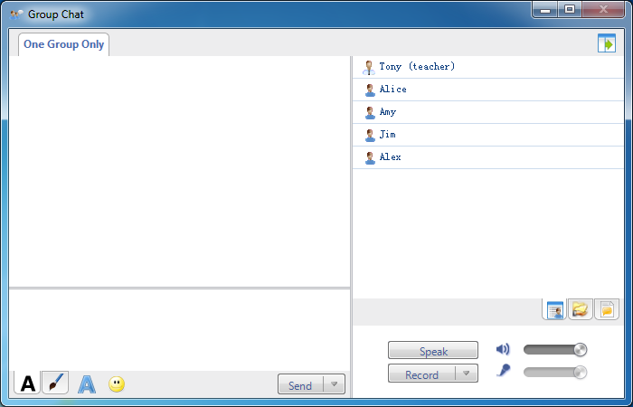

To Launch Group Chat

1.Click **Send** to chat with the students in the same group;

2.Click **Speak** to chat with others with voice;

3.Click **Record** to record the chat content;

There are lots of communications methods as below:

****Edit Messages:

**Change message font:** Set font, font style, size, color, effects, script of messages in the dialog;

 **Insert Emoticon:** Send emoticon to make chat easy and funny;

****Draw and Send Picture:

**Pen:** Draw the picture manually;

**Eraser:** Erase the picture;

**Undo:** Undo previous step;

**Rework:** Rework previous step;

**Color:** Choose the color;

**Select Background:** Select background from empty, small grid, medium grid and large grid;

There are also three different views in chat dialog as below:

Chat Members View

Teacher and students can check other members in the same group.

Shared Files View

Teacher and students can check the shared files, and double click the open the shared file.

Chat History View

Teacher and students can check chat history in this view.

|  |
| --- |
| **Notes** |
| * Students can view or download files shared by teacher. |
| * Click the drop-down arrow of  button to select the hotkey of Send. |

#### 7.16.2 Topic Chat

Students’ screen displayed as below when teacher launch **Topic Chat**. And students choose the topic they are interested in to chat with others in the same group.

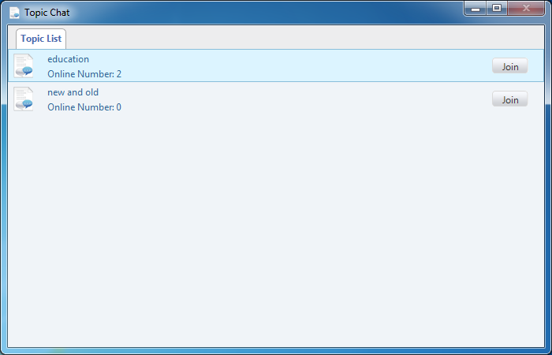

To Join a Topic

1.Click **Join** button beside the topic name in **Topic List**.

The following dialog will display on the students’ screen after they join one topic.

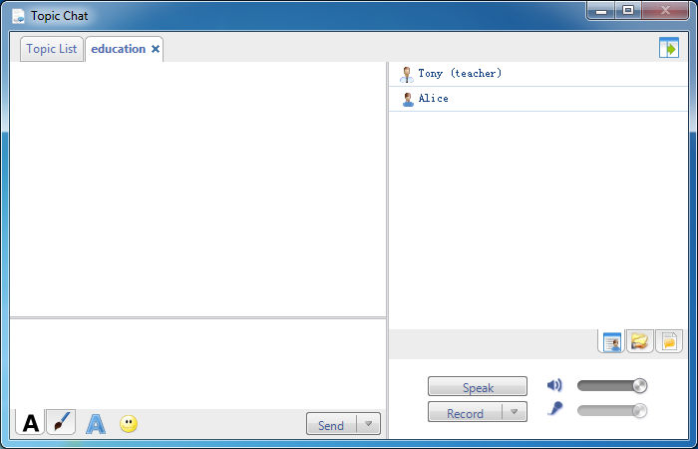

To Re-select a Topic

1.Select Topic List tab in Topic Chat dialog.

2.Click Join button beside the topic name in Topic List.

To Launch Topic Chat

1.Click Send to chat with the students in the same group;

2.Click Speak to chat with others with voice;

3.Click Record to record the chat content;

4.There are lots of communications methods as below:

Edit Messages:

Change message font: Set font, font style, size, color, effects, script of messages in the dialog;

 Insert Emoticon: Send emoticon to make chat easy and funny;

Draw and Send Picture:

Pen: Draw the picture manually;

Eraser: Erase the picture;

Undo: Undo previous step;

Rework: Rework previous step;

Color: Choose the color;

Select Background: Select background from empty, small grid, medium grid and large grid;

There are also three different views in chat dialog as below:

Chat Members View

Teacher and students can check other members in the same group.

Shared Files View

Teacher and students can check the shared files, and double click the open the shared file.

Chat History View

Teacher and students can check chat history in this view.

|  |
| --- |
| **Notes** |
| * Students can view or download files shared by teacher. |
| * Students can choose only one topic. |

**7.17 Quick Response**

Quick Response is the one feature of the software, this function can help teacher active classroom atmosphere.The following dialog will display at the low right corner of students’ screen after teacher launches Quick Response.

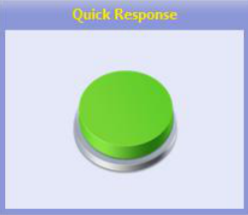

To Start Quick Response

1. Students start quick response after teacher raise up questions.

2. Click the green button to respond;

3. If certain student responds successfully, the prompt ”Respond succeed, please

answer…” will display in the top of his Quick Response dialog, meanwhile, the

camera of his computer will open automatically and his picture will be broadcast

to teacher and other students.

4.After student starts speaking,teacher judges.If the answer is wrong, it will show wrong in students interface and the change of the score will be reflected.

**7.18 Test**

Test is a quick test launched by teacher at any time in class.After teacher start test and select answer sheet.The following dialog will display at the low right corner of students’ screen.

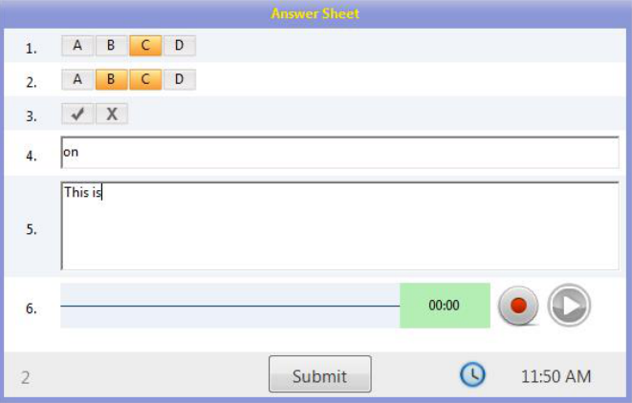

To Answer Multiple Choice Question

1.Click certain option to select this option;

2. Re-click certain option to deselect this option

To Answer True or False Question

1.Click √ or × to select this option;

2. Re-click certain option to deselect this option

To Answer Blank-Filling Question

1.Enter the answer in input box.

To Answer Essay Question

1. Enter the answer in input box

To Answer Oral Question

1.Click to record the answer;

2. Click to stop recording;

3.Click to play the recording record just now.

Click button to submit the answer after completing all answers.

**7.19 Oral Training**

In Oral Training, students can take part in “Reading-after” Practice or “Repeat Training” launched by teachers to improve language skills. Meanwhile, they can get the recommendation audio of other students and save their own repetition into MP3 files for after class review.

**7.19.1 Individual Training**

After teacher launch Normal Training, the student side supports autonomous recording, repeat recording, and submit recording files. The student side will be as below:

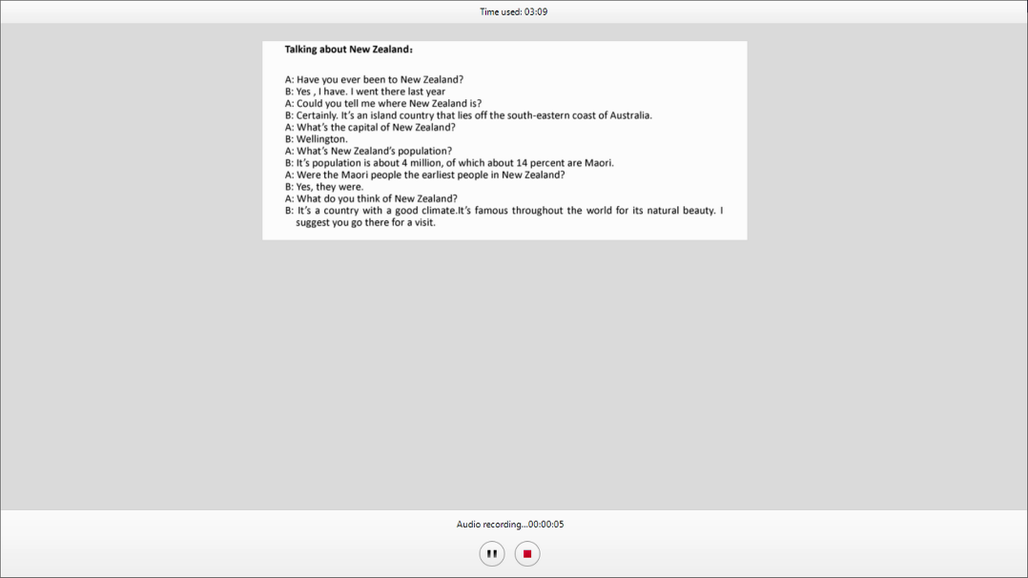

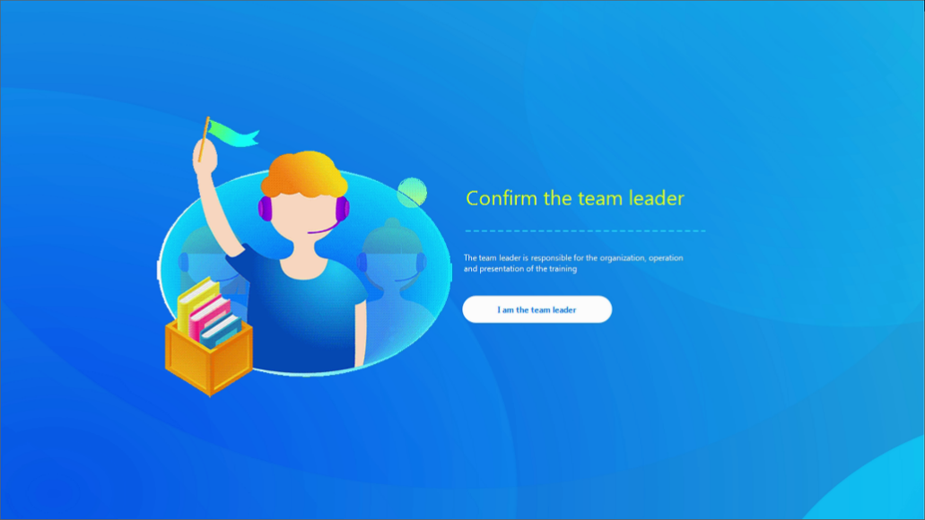

**7.19.2 Multiplayer Training**

When teacher launch “ Multiplayer Training”, the group leader start, stop and submit the recording in the student side.

Teacher grouping supports three modes. In “student interaction grouping”, student can recommend himself as team leader and choose his own team member from the seating chart. The student side will be as below:

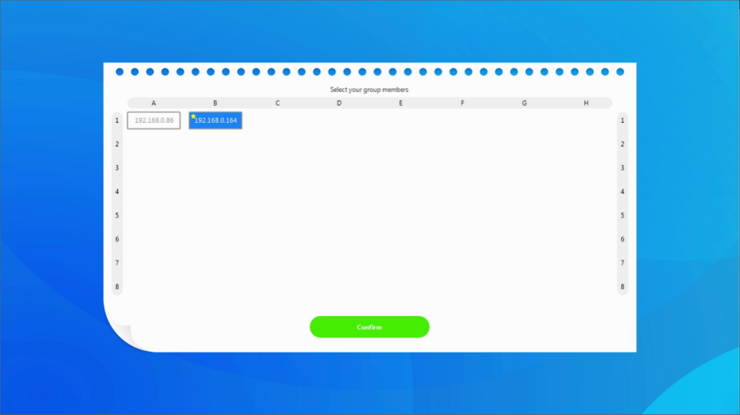

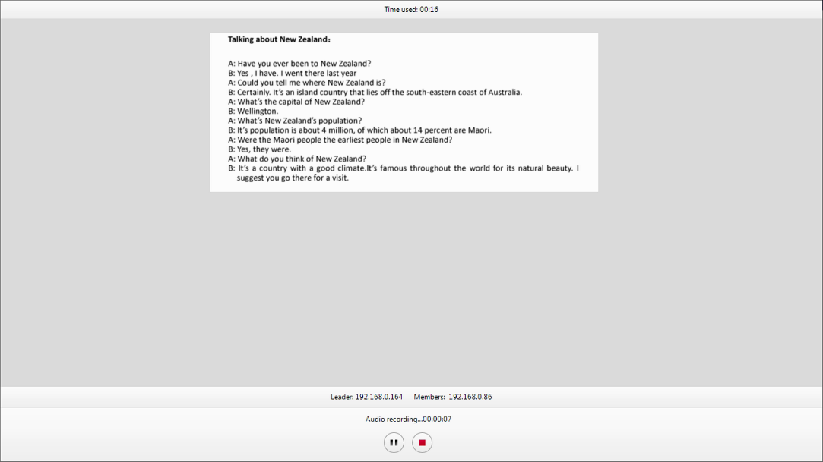

**To Launch Multiplayer Training**

1.After teacher click **“Start”**, group leader click **“Recording”** to begin the training.

2.After recording, group leader click **“stop”**. It supports repeat recording.

3.Click **“Submit”** to submit the recording.

#### 7.19.3 View recommended audio

Teacher can set the recording file submitted by the student as the recommended audio. After training, the system automatically sends the recommendation audio to the student side so student can download it in the lower right of the interface.

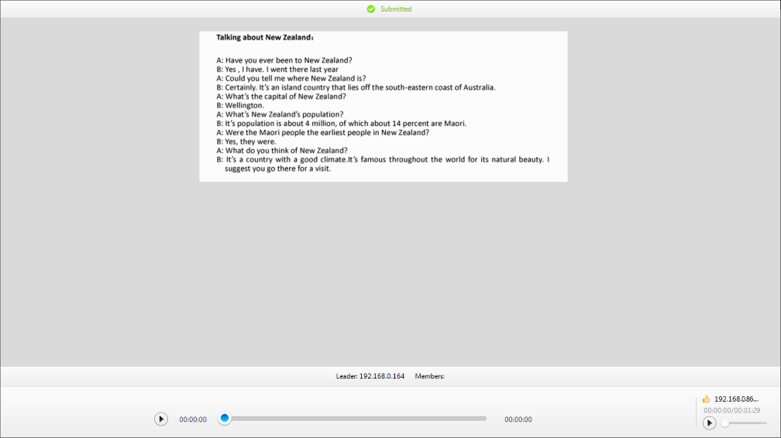

#### 7.19.4 View recording files

After close “Oral Training” in the teacher side, student can click “Full Recording Configuration” in the floating toolbar to select “View Recording File”.

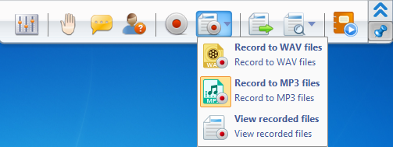

## 8 Student Side Settings

Student Side Settings are used to make better management for students.

To Enter Settings of Student Side

1.Click the  button on task bar. Click **Settings** button in pop-up menu, and then the following dialog will pop up.

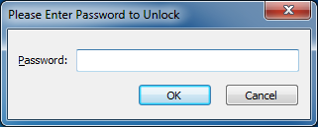

2.Enter the password in input box and click **OK**.

|  |
| --- |
| **Notes** |
| * The password to input is the password used to uninstall and manage the software. |

### 8.1 General

Administrator can set the boot directory to save user files in **General** tab.

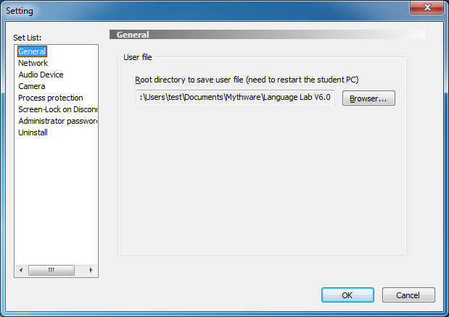

### 8.2 Network

Administrator can change the student’s channel in **Network** tab. Teacher can control the students of the same channel with him. If the student’s computer has more than one IP Address, administrator should choose one address to bind in this tab.

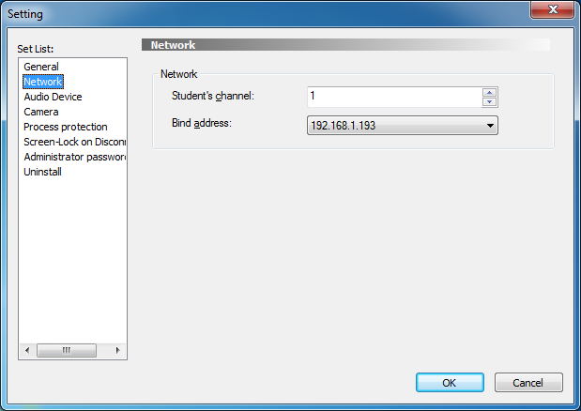

### 8.3 Audio Device

Administrator should select **Playback Device** and **Microphone** in this tab.

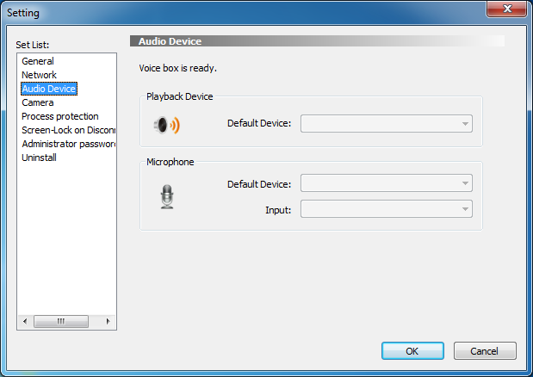

### 8.4 Camera

Administrator can deploy the camera of student’s computer in this tab.

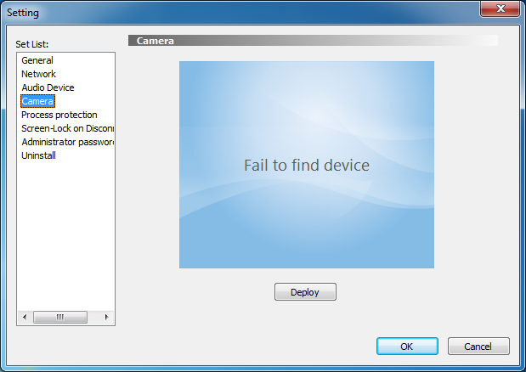

To deploy camera:

1.Click **Deploy** button, the following dialog will pop up;

2.Select a camera in **Device** column;

3.Click **Close.**

4.Click **OK** to complete deploy.

### 8.5 Process protection

It is used to prevent students from ending the process through Task Manager to escape from the teacher side control program, so that students can no longer terminate the application process by windows task manager or most of other killing process tools.

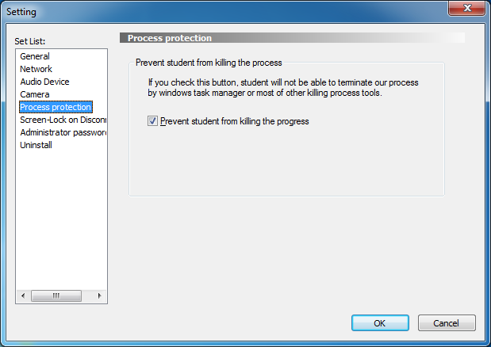

### 8.6 Screen-Lock on Disconnect

In daily teaching, students sometimes unplug the network cable or disable the network card to escape from teacher's control. After setting **Screen-Lock on Disconnection**, when being monitored students initiatively disable the connection, the program will lock student's screen immediately. And students need to press hotkey and input administrator password to unlock.

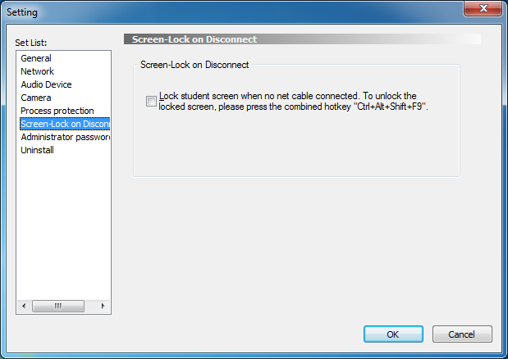

### 8.7 Administrator Password

Administrator can change the **Administrator Password** in this tab.

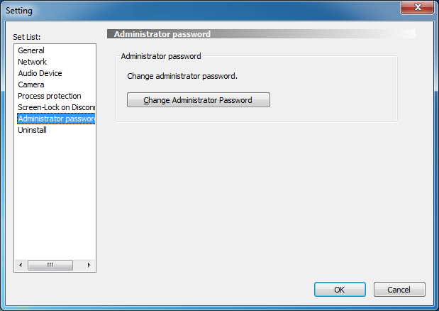

### 8.8 Uninstall

Administrator can uninstall student softwarein this tab.

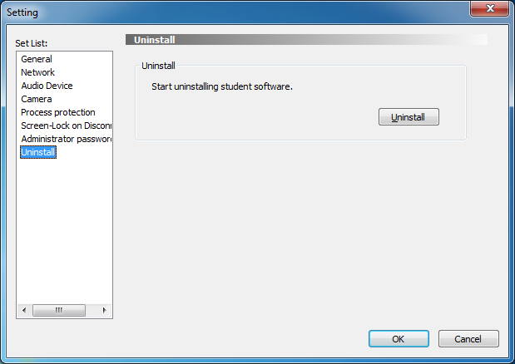

**8.9 registration**

When all the computers are authorized through "terminal authorization", the student side will appear "registration"When customers use dongle registration, serial number registration or other ways, the student side remains the same.

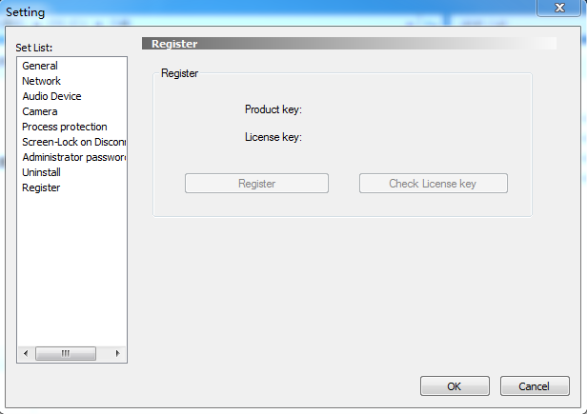

# END-USER LICENSE AGREEMENT

The software is protected by copyright laws and international treaty provisions. Nanjing Universal Networks Co., Ltd. own and retain all right, title and interest in and to the Software, including all copyrights, patents, trade secret rights, trademarks and other intellectual property rights therein. You acknowledge that your possession, installation, or use of the Software does not transfer to you any title to the intellectual property in the Software, and that you will not acquire any rights to the Software except as expressly set forth in this Agreement. You agree that any copies of the Software and Documentation will contain the same proprietary notices which appear on and in the Software and Documentation. You may not rent, lease, loan or resell the Software. You may not permit third parties to benefit from the use or functionality of the Software via a timesharing, service bureau or other arrangement, except to the extent such use is specified in the applicable price list, purchase order, or product packaging for the Software. You may not transfer any of the rights granted to you under this Agreement. You may not reverse engineer, decompile, or disassemble the Software, except to the extent the foregoing restriction is expressly prohibited by applicable law. You may not modify, or create derivative works based upon, the Software in whole or in part. You may not copy the Software or Documentation. You may not remove any proprietary notices or labels on the Software. All rights not expressly set forth hereunder are reserved by Nanjing Universal Networks Co., Ltd. Nanjing Universal Networks Co., Ltd. reserves the right to periodically conduct audits upon advance written notice to verify compliance with the terms of this Agreement. Some functions and features of this software are under the auspices of the Intel, they are "Group Management", "Quiz", "Bounding Window", "Remote Setting" and "UI Design", you can only install and use the software on the Intel CPU integrated computers. If you can not accept the limitation, please don't install this software, and contact us for unlimited versions and other cooperation.

# Technical Support

The software Technical Support team welcomes your questions and comments.

If you experience any difficulty with the software, you may first want to contact your local agents, as they may be able to solve the problem more quickly.

Relevant telephone, fax and email information contained in the software:

Phone: +86-25-66987899

Fax: +86-25-66987898

Mail: [sales@mythware.com](mailto:sales@mythware.com)

Website: www.mythware.com

When you call technical support, it is helpful if you have accessed to your software during the call. The support representative may ask you for the following information:

When you purchased the product.

The agent's name.

The version of your operation system.